BEPTON PARISH COUNCIL
--------------------------------------

Chairman: Mrs Rosalind Hart
Clerk: Mrs. Lorraine Grocott, BEM, BA Hons (Local Policy)
Tel. H:01428 741393 – M:07811 885572
Email: clerk.beptonparishcouncil@gmail.com Website – www.bepton.org

MINUTES of BEPTON PARISH COUNCIL
Thursday 24th September 2026 in The Park House Hotel, Bepton

Present: Mrs R Hart, (in the Chair), Mr J Beckett, Mr M Salmon, Mr P McCulloch,
Mr B Tyrrell-Evans (late)
Cllr Y Gravely, County Councillor (part)
Cllr D Merritt, District Councillor
Public – Mr Simon Hawksworth
431. Apologies/Absent – All present.

432. Casual Vacancy – CDC have advised that the Council can co-opt another person.
Mrs Hart will be resigning as Chairman of the Council and as a Councillor at this meeting.
The District Council will be advised of another Casual Vacancy.
433. Declaration of Interests of Members – There were none.
434. Public Participation – It was hoped Mr Simon Hawksworth will be become a councillor.

435. Minutes of the Council Meeting 16th July – Approved and signed.

436 Report from the County Councillor – Cllr Y Gravely
- Local Government Reorganisation for parish councils. The Government has announced that it has paused the Local Government Reorganisation (LGR). The CDC elections will proceed in May. The WSCC and CDC will continue in their current format are for another year. Strategies are in place for Mayoral elections.
- Angel Hotel – Progress is being made. They are working to resolve the car parking issue.
- WSCC has endorsed a refreshed programme of Growth Deals that will invest in the county’s high street, green spaces, transport links and community facilities.
- There are virtual parish briefings planned in October on highways, and Winter Readiness.
- A service helping thousands of people recover following illness, injury or surgery is proving central to WSCC work to develop sustainable adult social care services.

437. Report from the District Councillor – Cllr D Merritt
- Encouraging tourism in Midhurst – More local events are being planned in the town including Midhurst Music and Movies afternoon/evening. A Laser show is being planned for 2027.
- Land at The Grange – This development is continuing to move forward.
- Speed Watch Group – ~The Midhurst group is continuing to go from strength to strength.
- Water Main Replacement – Bugshill Lane and Bell Lane – The project will involve laying approximately 4.7km of new water main along Bugshill Lane and Bell Lane starting 7th September 2026. It is a major project that will be completed in several phases over a period of about 7 months.
- Midhurst Police Station – Cllr Merritt continues to campaign for the reopening of the public front desk, alongside a stronger and more visible policing presence across Midhurst and the surrounding villages.
- Checking-in with Midhurst Businesses – Cllr Merritt carries out regular visits to local businesses to hear their views and concerns.

Minutes of Bepton Parish Council meeting 24th September 2026

- Development Management Planning Reforms and National Scheme of Delegation –
As a result of the governments planning reforms the parish voice will be smaller. The parish council will still have a statutory voice, but decisions will be made by a smaller planning committee. They will decide whether to ‘call-in’ an application. This is being driven by Central Government. The Red Card system has been withdrawn. If the council has any concerns about an application, they should refer them to the District Councillor.

438. Matters arising from the Minutes – Matters were covered in the Chairman’s items.

439. Chairman’s Items – Mrs R Hart
a) Bepton Road Traffic Regulations Order – The traffic signs are now in place. There has been one complaint that the signs were not in the right place. Mrs Hart advised that Highways are very specific as to where they are sited.
b) The Country Inn – is now open. As the weather changes the tables and chairs will be moved inside.
c) Funding request from Arun and Chichester Citizens Advice Bureau (CAB). The meeting discussed this and decided not to give a donation. The council felt it would rather support the local Community Hub in Midhurst.
d) Celebration plan for the 1550th anniversary of Sussex on 9th June 2026 – Parties and celebrations will be planned. Hopefully a grant will be provided by the District Council for this special event.
e) CEO of Cowdray Park has written to advise that they will be applying for the construction of a swimming pool at Church Farm. A site visit has been offered.

440. Finance Report – Mrs L Grocott a)
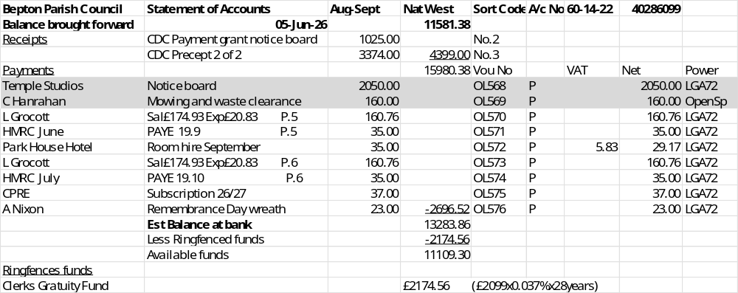

These payments were approved.

b) Grant of £1025 received from CDC for the notice board.
c) Annual Governance and Accountability Return (AGAR) – There are changes for Smaller Authorities Proper Practices on the horizon. The Clerk will try and attend a session on Zoom/Teams.
d) Internal auditor – The clerk suggested it is time to change our internal auditor in line with current practice and that is to appoint an auditor from an accountable firm. She will contact Mark Mulberry for the name of a local auditor who meets the new requirements.
e) Request for financial support for more daffodils for Severals – this was agreed.
f) Precept preparation for 2027-28 – The Clerk will prepare a Draft Budget with Mr Salmon for presentation at the November meeting.
g) NALC – 2026-27 National Salary Award – Back dated to 1 April 2026 – The Clerk will receive an increase of 61pence per hour. SPC 24 £35,412 to £36,581.

Minutes of Bepton Parish Council meeting 24th September 2026
---------------------------------------------------------------------------------------------------------------------------

441. Planning Report – Mr J Beckett

SDNP PLANNING RESPONSE TO APPLICATIONS: -
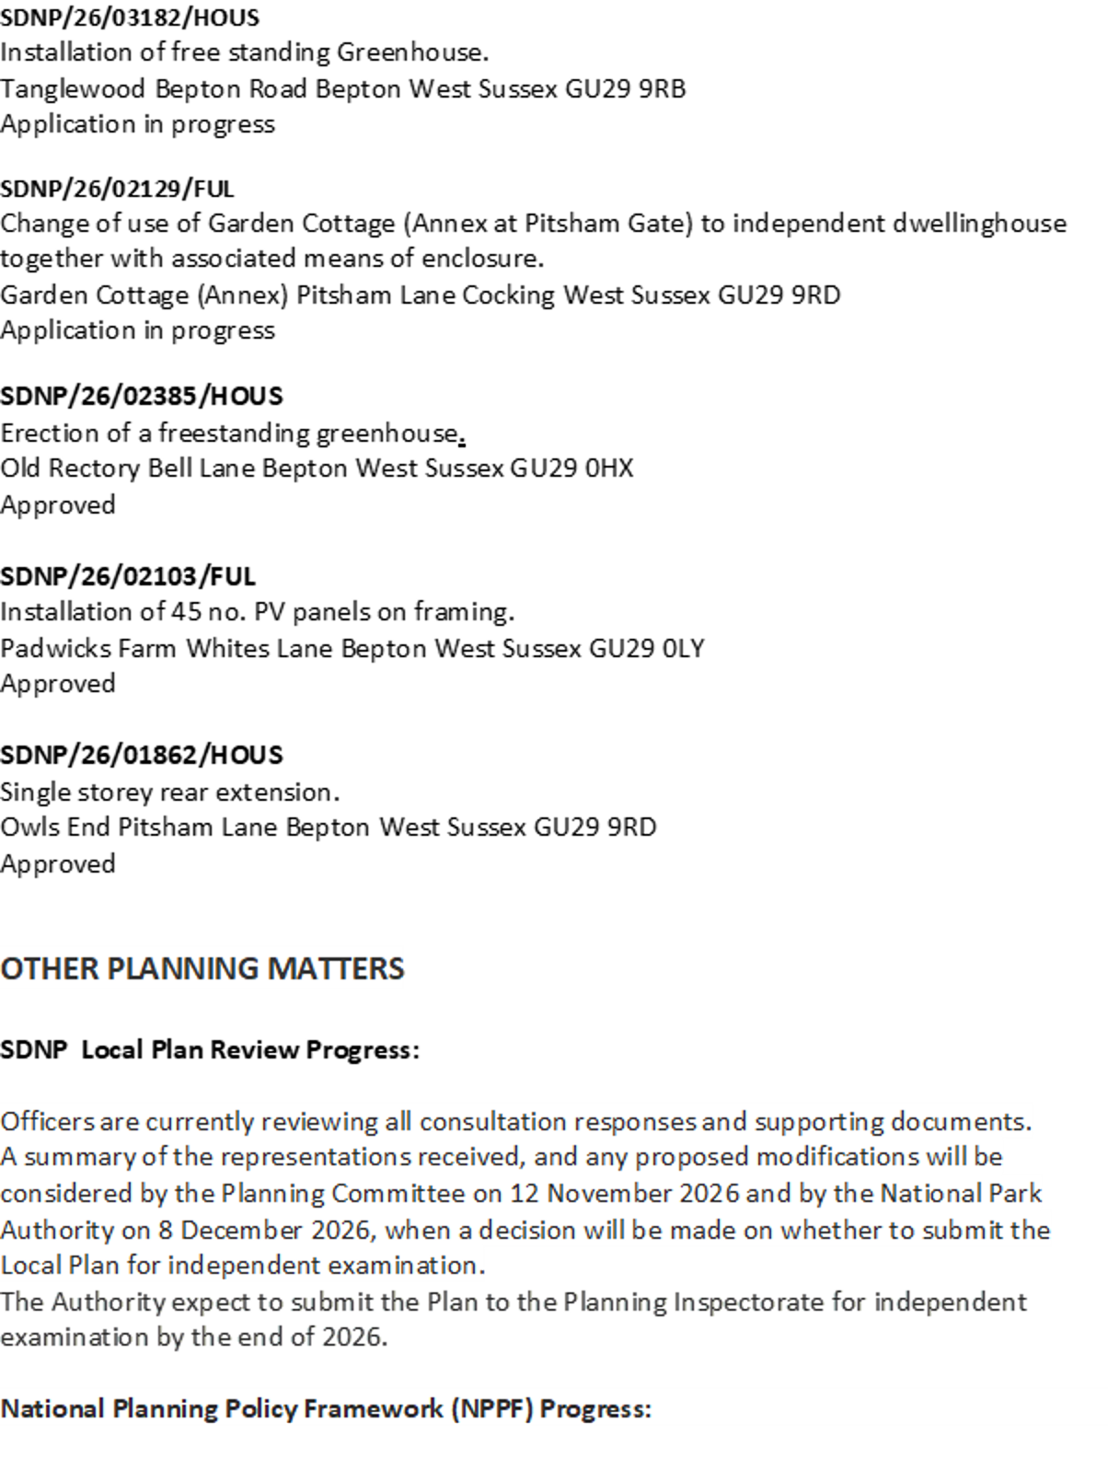

Minutes of Bepton Parish Council meeting 24th September 2026
------------------------------------------------------------------------------------------------------------------------

422. SDNPA Parish Meeting – Wednesday 30th September – Mr Salmon to attend.

443. Website – Parish ONLINE – address Bepton-pc.gov.uk – The new website and email addresses have now ‘bedded in’. The website is gradually being developed. Mr Salmon is seeking photos for the website. He may make a collage using a range of local features.

444. LOGO for Bepton – The idea was discussed. Mr Salmon to bring some ideas to the next meeting.

445. Winter Resilience Plan 2026-27 – The Plan has been revised. The local contacts will be Mr Tristan Parks, ACS as the Farmer Contractor and Mr McCulloch the local councillor. The contact at WSCC will arrange with Mr Parks for copies of the PLI certificates.

446. Environment/Highways/Rights of Way
The local Access Ranger, Kenin Dewitt will be organising the Public Rights of Way
inspection in October. Issues with paths, including vegetation, and furniture (signage stiles, bridges etc.) will be recorded and logged. In due course maintenance work will be prioritised for delivery by their contractor. The overgrown vegetation along Minching Lane was mentioned.

447. Other meetings
a) Sussex PCC – Autumn engagement 11am-12.30pm via Zoom
b) CDC All Parishes meeting via Teams – 6.30pm Monday 12th October – JB
c) CDALC Meeting via Zoom – 6.30pm Monday 26th October
d) MYBus AGM – 7pm 4th November – The Parish Room, Midhurst Catholic Church - JB

448. Date of the next meeting 26th November 2026

449. Presentation and Vote of Thanks - Following the meeting, there was a presentation of gifts to the retiring Chairman Mrs Rosalind Hart. Thanks were expressed for her long commitment and contribution to the council both as a councillor, the planning representative and for 7 years as chairman.

CONCLUSION 8.30PM

Chairman: _______________________

These Minutes are unconfirmed until signed by the Chairman.

